Ninth Street Dance   
Media Improvement Proposal

Substantiating Ninth Street Dance’s Media Usage for the Future

Julia Warren | 10/4/2018 | ENGL 6715

# Executive Summary

This proposal puts forward a three-pronged strategy to improve Ninth Street Dance’s social and other media usage, based on the following weaknesses found during an evaluation of current and potential practices:

1. Sporadic use of the business’s Facebook page
2. Instagram account non-existent
3. Web redesign and paper brochure overhaul needed.

In order to strengthen these aspects of Ninth Street Dance’s communication practices, the following projects are proposed:

1. *Facebook communication revamp*
2. *Instagram account development*
3. *Redesign of website and paper brochure*

Investing in the above practices will show that Ninth Street Dance is committed to obtaining and retaining a strong client base. It will also enable Ninth Street Dance to control its own online presence and attempt to rival its fantastic word-of-mouth reputation.

We believe that with an initial investment of only $800, and a monthly investment thereafter of $275 per month, Ninth Street Dance’s online communication practices can keep up with and eventually exceed its word-of-mouth reputation. New student interest will be at an all-time high, and the adult dance community in Durham will finally have a central place to thrive.

TO: Dr. Cox

FROM: Julia Warren

SUBJECT: Ninth Street Dance Media Improvement Proposal

DATE: 10/04/2018

# Purpose

This proposal outlines a three-pronged strategy to improve Ninth Street Dance’s communication practices. With improved social media usage, Ninth Street Dance could maximize its enrollment each session. Firstly, we will focus on improving Ninth Street Dance’s Facebook practices by conforming to more conventional Facebook business page usage. Second, we will prepare, launch, and maintain a studio Instagram account that appropriately highlights the studio’s aesthetic while also conveying class combination examples and highlighting the studio’s instructors, if they are on Instagram.

# In addition to presenting new social media practices for Ninth Street Dance, this proposal will also detail a third task for redesign: the studio’s website and paper brochure. Revising the website will bring the studio up-to-date with internet practices; revising the paper brochure will be a convenience for the studio’s clientele.

# Problem

Ninth Street Dance’s current communication practice does have strengths: its email contact list is used appropriately, the main business Facebook page has a nice following, the associated Facebook group is active, and the brand is recognizable in the community. However, the weak points identified in the media improvement project certainly detract from the studio’s potential for maximum online interactivity. Ninth Street Dance’s media were evaluated on five criteria: use of visuals, interactivity, ease of content management, cost and investment, and outreach. Specific to this proposal are the following:

* Sporadic use of the business’s Facebook page: based on the criteria above the Facebook page has great potential to maximize its usage in each category. Facebook has the ability to share multiple types of media, it leaves many options for interacting with customers, external software can be used to schedule posts, business pages are free unless sponsoring a post, and the page already has over 1,000 likes.
* Instagram launch: the studio’s cool aesthetic and friendly environment don’t come through on the black-background website or the business-like Facebook page. Communication is powerful where images are present, and dance is a visual art. These two ideas blend perfectly and support the notion that an Instagram account should be launched for Ninth Street Dance.
* Web redesign and paper brochure overhaul: these are lumped together because so much branding has gone into each form of media. Ninth Street Dance’s brand is recognizable, but the website is far from timeless. The black background and side menu with no dynamic pages are things of the past, and while the very cool building that houses the studio is also very old, the studio should show that it can keep up with the times (as its instructors do). Additionally, the paper brochure should be reformatted in the revamped branding and also turned into a calendar in order to maximize convenience for students who pick up the brochure each semester.

# Three-Pronged Approach

Each below project has an initial hurdle, followed by regular work that will need to be done. This approach focuses on the potential for engagement in each form of media and maximizes the saturation without being overbearing for followers.

Each project should occur concurrently, with some launches lasting longer than others; ultimately, this plan for improving Ninth Street Dance’s media will be sustainable and beneficial.

## Project 1: Facebook Communication Revamp

|  |  |
| --- | --- |
| Launch Tasks | * Gauge instructors’ interests * Draft a template for spotlight posts * Evaluate feasibility of posting videos from classes * Draft a schedule for instructors providing class videos |
| Regular Investment | * Schedule at least three posts per week about dance * Send out regular blast asking instructors for posts if desired |
| Costs | * Two hours per week |

1. Solicit class/combination videos from instructors
   1. Post at least once a week
2. Instructor spotlight posts
   1. Can use stock information
   2. Post twice a week (lots of instructors!)
3. Post about other dance events in the community
   1. As needed
4. Anticipated cost: 2 hours/week

Facebook Project Summary

|  |  |
| --- | --- |
| Launch Tasks | * Gauge instructors’ interests * Evaluate feasibility of posting videos from classes * Draft a schedule for instructors providing class videos |
| Regular Investment | * Schedule at least four posts per week * Keep up with instructor accounts for new videos |
| Costs | * One hour per week |

## Project 2: Instagram Account Development

1. Develop account identity (logo, bio, gather instructors’ account names)
   * 1. Around 3 weeks
2. Re-gram instructor posts
   * 1. Twice a week
3. Pictures of studio and class
   * 1. Twice a week
     2. Class videos
4. Anticipated cost: 1 hour/week

Instagram Project Summary

## Project 3: Redesign Website and Paper Brochure

1. Slightly update the branding
   1. The logo itself is recognizable and timeless, but a higher-definition version should be put into circulation.
   2. 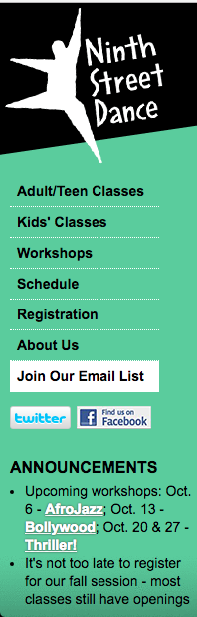Website is easily navigable, but the light text on dark background and basic scheme are a bit behind the times.
      1. The included images show the Facebook icon and the website’s tool bar.
      2. The folksy silhouettes can stay, but the font, the coloring, and positioning of the text should be made consistent.
2. Paper brochure will include large class week-long calendar on one side and have class descriptions on the other side
3. Anticipated cost
   1. **Website revision**: around $500 including brand update
      1. 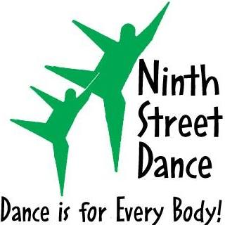Timeline: two months
   2. **Paper brochure revision**: around $200
      1. Timeline: one month

|  |  |
| --- | --- |
| Launch Tasks | * Brand revision * Website update * Paper brochure redesign |
| Timelines | * Paper brochure revision: one month * Brand revision: one month * Website redesign: two months |
| Costs | * Brand and website redesign: around $500 * Paper brochure revision: around $200 |

Branding, Website, and Brochure Project Summary

# Considerations

## Intellectual Property

Instructors may be hesitant to share their choreography publicly. Before this project launches, each instructor should discuss their level of comfort with regards to having their work shared on social media.

## Student Privacy

Currently, students do not have an option sign an image non-release form. This possibility should be explored in order to avoid any complications with posting class pictures or videos.

# Total Investment

## Launch Costs

|  |  |  |
| --- | --- | --- |
| Task | Rate | Total |
| Manpower to sketch post templates | $10*10 hours | $100 |
| Brand Revision | Market rate | $200 |
| Website Revision | Market rate | $300 |
| Paper Brochure Revision | Market rate | $200 |
| **TOTAL** |  | **$800** |

## Regular Investment

|  |  |  |
| --- | --- | --- |
| Task | Cost | Total |
| Facebook | $10*2 hours/week | $80/month |
| Instagram | $10*2 hours/week | $80/month |
| Website | $15/month | $15/month |
| Paper Brochure | $400/four months | $100/month |
| **TOTAL** |  | **$275/month** |